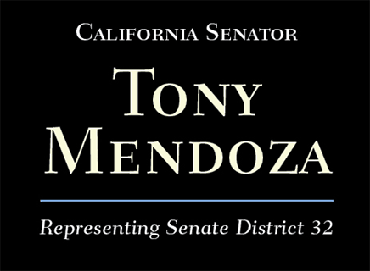

http://sd32.senate.ca.gov/support-648

Please Support SB 648
Thank you for your interest in SB 648, which will protect seniors and their families by establishing state oversight for elder care referral agencies.
Below are sample letters that you can print and send to the Department of Social Services and the Office of Governor Jerry Brown.
You can also call and report your stories and experiences to the Department of Social Services’ Adult Protective Services Hotline at 877-477-3646 (Los Angeles County) and 800-451-5155 (Orange County).
If you would like more information on SB 648, please email Mahreen Alam in my office atmahreen.alam@sen.ca.gov or call my office at (916) 651-4032.
A fact sheet on SB 648 may be found here.
Status of SB 648 may be found here.
Thank you for your help and support for this important bill.

The Honorable Edmund G. Brown
Governor, State of California
State Capitol, Suite 1173
Sacramento, CA 95814
Re: Support of Senate Bill (SB) 648 by Senator Tony Mendoza
Dear Governor Brown,
I urge you to support SB 648, authored by Senator Tony Mendoza, which would protect seniors and their families from unscrupulous private referral agencies.
[Please insert description of your interest/involvement in senior issues – DELETE if blank]
SB 648 provides much-needed oversight, disclosures, and standards of conduct for an industry that provides an important service for California’s senior population. Many referral agencies hold themselves to a high standard, but many others provide incompetent and unethical services in search of a quick dollar, usually to the detriment and harm of the senior. Referral agencies are paid by commission or a finders’ fee, typically calculated as a percentage of the seniors monthly rent, creating an incentive for the referral agent to place the senior in a specific facility or one where the agency has an exclusive referral contract. This can create conflicting motives.
[Please insert personal experiences with referral agencies – DELETE if blank]
The search for a care facility for a loved one often occurs following an accident, illness, or hospital stay that results in decreased independence. Seniors and their families can be extremely vulnerable in these times, especially given the enormity of making such important care and living decisions. Given the significant role that referral agencies can play in care decisions at very stressful junctures in an elder’s life, some referral agencies can use this as an opportunity to take advantage of the aging population, and other referral agencies may simply not be competent or sufficiently knowledgeable to adequately advise seniors as to the best care options.
SB 648 would ensure that seniors and their families are protected from referral agencies that put profit ahead of the seniors’ best interests or healthcare needs.
I urge you to sign this important bill into law.
Sincerely,

Mr. Robert Smith
Deputy Director, Office of Legislation
California Department of Social Services
744 P St.
Sacramento, CA 95814
Re: Support of Senate Bill (SB) 648 by Senator Tony Mendoza
Dear Deputy Director Smith,
I urge you to support SB 648, authored by Senator Tony Mendoza, which would protect seniors and their families from unscrupulous private referral agencies.
[Please insert description of your interest/involvement in senior issues – DELETE if blank]
SB 648 provides much-needed oversight, disclosures, and standards of conduct for an industry that provides an important service for California’s senior population. Many referral agencies hold themselves to a high standard, but many others provide incompetent and unethical services in search of a quick dollar, usually to the detriment and harm of the senior. Referral agencies are paid by commission or a finders’ fee, typically calculated as a percentage of the seniors monthly rent, creating an incentive for the referral agent to place the senior in a specific facility or one where the agency has an exclusive referral contract. This can create conflicting motives.
[Please insert personal experiences with referral agencies – DELETE if blank]
The search for a care facility for a loved one often occurs following an accident, illness, or hospital stay that results in decreased independence. Seniors and their families can be extremely vulnerable in these times, especially given the enormity of making such important care and living decisions. Given the significant role that referral agencies can play in care decisions at very stressful junctures in an elder’s life, some referral agencies can use this as an opportunity to take advantage of the aging population, and other referral agencies may simply not be competent or sufficiently knowledgeable to adequately advise seniors as to the best care options.
SB 648 would ensure that seniors and their families are protected from referral agencies that put profit ahead of the seniors’ best interests or healthcare needs.
I urge you to support this important bill.
Sincerely,

